***Practical 6***

Aryaman Gautam

J001

1. Blink any text on LCD

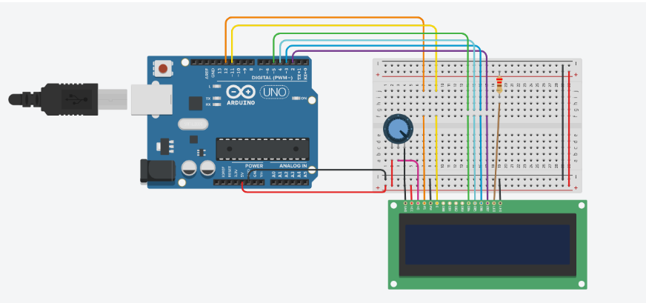

#include <LiquidCrystal.h>

LiquidCrystal lcd(12, 11, 5, 4, 3, 2);

void setup () {

lcd.begin(16,2);

}

void loop() {

lcd.clear();

lcd.setCursor(0,0);

lcd.print ("Hello World");

delay(1000);

lcd.clear();

lcd.setCursor(0,0);

lcd.print ("");

delay(1000);

}

1. Display customer name taken as input using serial monitor on LCD

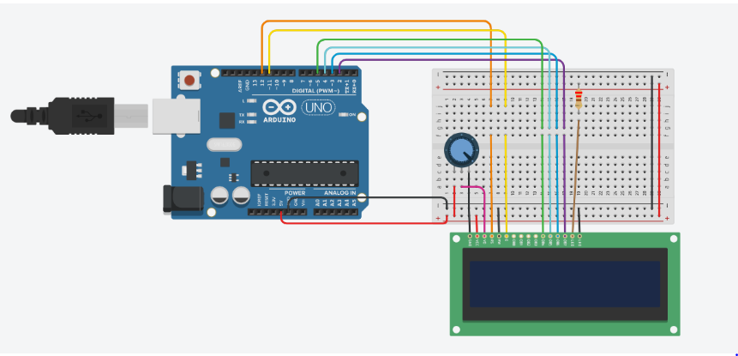

#include <LiquidCrystal.h>

LiquidCrystal lcd(12, 11, 5, 4, 3, 2);

void setup() {

Serial.begin(9600);

Serial.setTimeout(100);

lcd.begin(16, 2);

lcd.print("Serial input");

delay(1000);

}

void loop() {

if (Serial.available()>0){

lcd.setCursor(0,0);

lcd.clear();

lcd.cursor();

lcd.blink();

lcd.print("Serial input:");

String x=Serial.readString();

lcd.print(x);

}

}

1. Display potentiometer reading on LCD

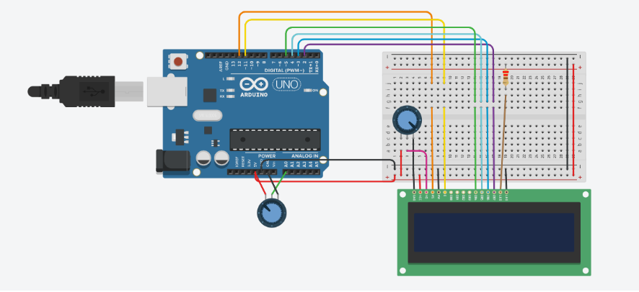

#include <LiquidCrystal.h>

LiquidCrystal lcd(12, 11, 5, 4, 3, 2);

void setup() {

lcd.begin(16, 2);

pinMode(A0, INPUT);

}

void loop() {

int read = analogRead(A0);

lcd.setCursor(0, 0);

lcd.print(read);

}

1. Display tilt sensor reading on LCD

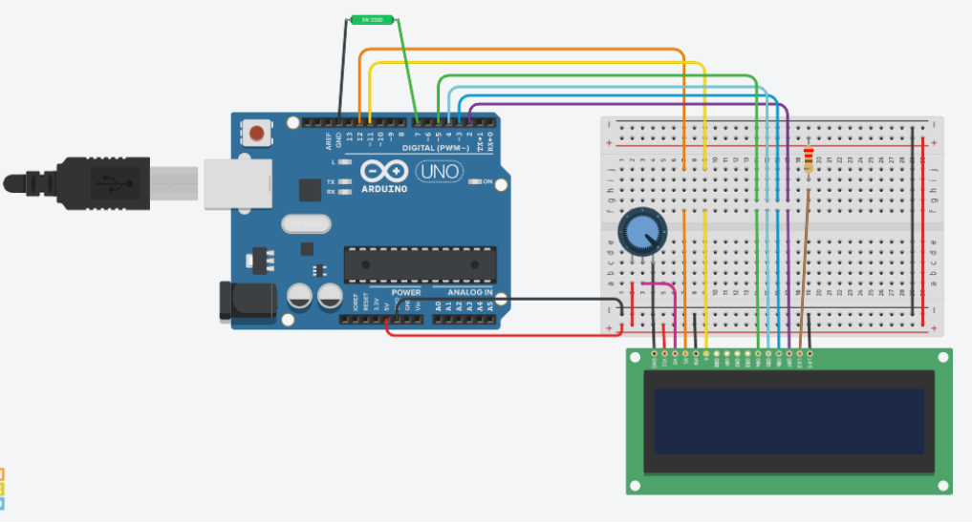

#include <LiquidCrystal.h>

LiquidCrystal lcd(12, 11, 5, 4, 3, 2);

void setup() {

lcd.begin(16, 2);

pinMode(7, INPUT);

}

void loop() {

int read = analogRead(7);

lcd.setCursor(0, 0);

lcd.print(read);

}

1. Display temperature sensor reading on LCD

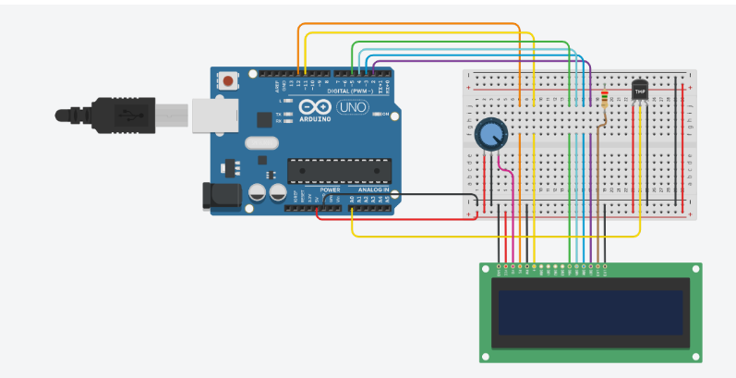

#include <LiquidCrystal.h>

LiquidCrystal lcd(12, 11, 5, 4, 3, 2);

int sensePin = A0;

int sensorInput;

double temp;

void setup()

{

pinMode(13, OUTPUT);

lcd.begin(16, 2);

Serial.begin(9600);

}

void loop()

{

lcd.setCursor(0, 0);

sensorInput = analogRead(A0);

temp = (double)sensorInput / 1024;

temp = temp * 5;

temp = temp - 0.5;

temp = temp * 100;

lcd.print("Temperature: ");

lcd.setCursor(0, 1);

lcd.print(temp);

lcd.print(" Celsius");

}

1. Display LDR reading on LCD

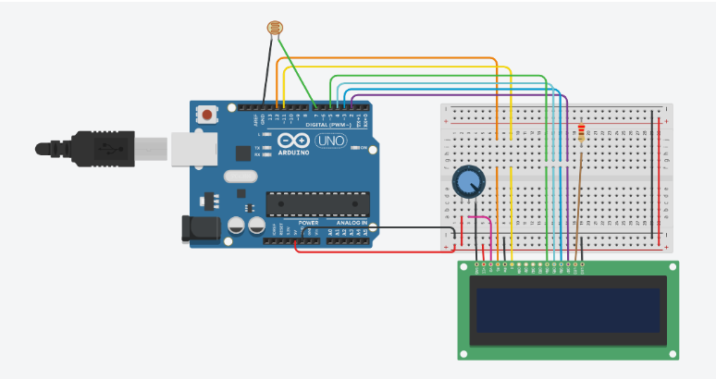

#include <LiquidCrystal.h>

LiquidCrystal lcd(12, 11, 5, 4, 3, 2);

void setup() {

lcd.begin(16, 2);

pinMode(7, INPUT);

}

void loop() {

int read = analogRead(7);

lcd.setCursor(0, 0);

lcd.print(read);

}

1. If tilt is observed then buzzer should ring and LCD should display warning

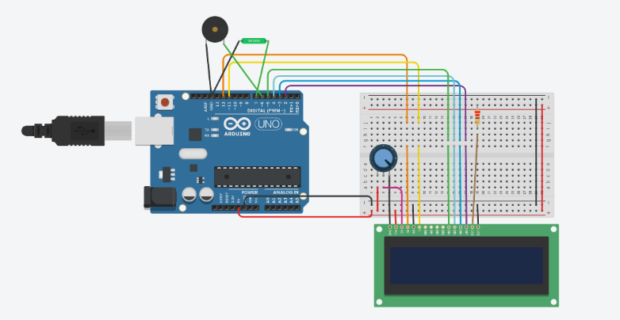

#include <LiquidCrystal.h>

LiquidCrystal lcd(12, 11, 5, 4, 3, 2);

void setup() {

lcd.begin(16, 2);

pinMode(7, INPUT);

}

void loop() {

int read = analogRead(7);

if (read == 0){

lcd.setCursor(0, 0);

lcd.print("No warning");

noTone(6);

}

else{

lcd.setCursor(0,0);

lcd.print("Warning");

tone(6, 440);

delay(1000);

noTone(6);

}

}

1. If button is pressed, the shaft should rotate by 180 and buzzer should ring and LCD should display OPEN and CLOSED otherwise

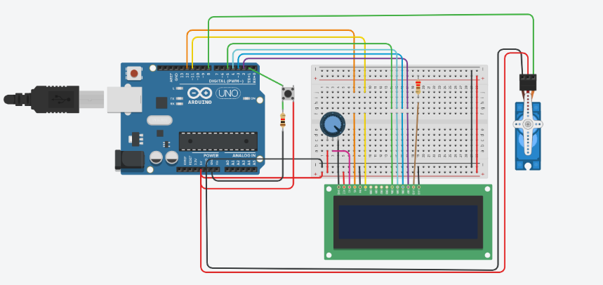

#include <LiquidCrystal.h>

#include<Servo.h>

Servo myservo;

LiquidCrystal lcd(12, 11, 5, 4, 3, 2);

void setup() {

lcd.begin(16, 2);

myservo.attach(8);

pinMode(1, INPUT);

}

void loop() {

int read = digitalRead(1);

if (read == HIGH){

lcd.clear();

lcd.setCursor(0, 0);

lcd.print("Open");

myservo.write(90);

delay(1000);

}

else{

lcd.clear();

lcd.setCursor(0,0);

lcd.print("Closed");

myservo.write(0);

delay(1000);

}

}

1. LCD should display “WALK” when traffic signal is RED and “STOP” when signal is green (use own settings for traffic signal)

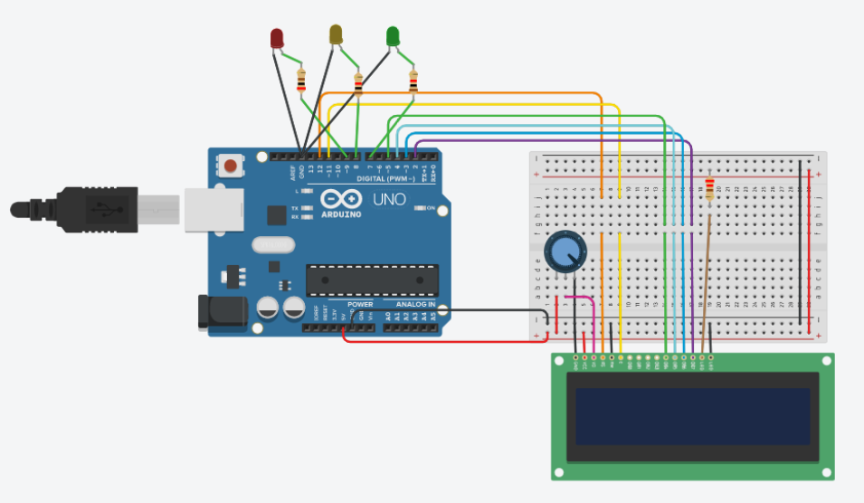

#include <LiquidCrystal.h>

LiquidCrystal lcd(12, 11, 5, 4, 3, 2);

void setup() {

lcd.begin(16, 2);

pinMode(7, OUTPUT); // green

pinMode(8, OUTPUT); // yellow

pinMode(9, OUTPUT); // red

}

void loop() {

for (int i = 9; i>=7; i--){

digitalWrite(i, HIGH);

lcd.clear();

lcd.setCursor(0,0);

if (i==9){

lcd.print("WALK");

delay(5000);

}

else if (i==8){

lcd.print("LOOK");

delay(5000);

}

else{

lcd.print("STOP");

delay(5000);

}

digitalWrite(i,LOW);

}

}